Profile of the

North Central Narcotics 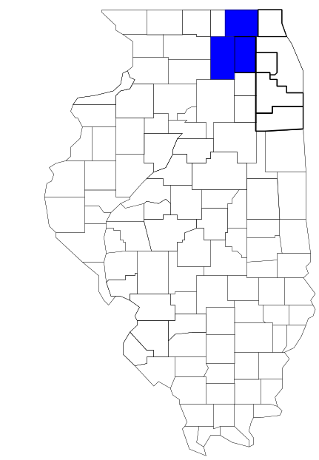Task Force

Prepared by

The Research and Analysis Unit of the
Illinois Criminal Justice Information Authority

George H. Ryan, Governor
Peter B. Bensinger, Chairman
Candice M. Kane, Executive Director

March 2001



ILLINOIS
CRIMINAL JUSTICE
INFORMATION AUTHORITY

This project was supported by Grant # 99-DB-BX-0017, awarded to the Illinois Criminal Justice Information Authority by the Bureau of Justice Assistance, Office of Justice Programs, U.S. Department of Justice. The Assistant Attorney General, Office of Justice Programs, coordinates the activities of the following programs, offices and bureaus: Bureau of Justice Assistance, Bureau of Justice Statistics, National Institute of Justice, Office of Juvenile Justice and Delinquency Prevention, and the Office for Victims of Crime. Points of view or opinions contained within this document are those of the authors and do not necessarily represent the official position or policies of the U.S. Department of Justice.

Illinois Criminal Justice Information Authority
120 S. Riverside Plaza, Suite 1016
Chicago, Illinois 60606-3997
Telephone (312) 793-8550
Telefax (312) 793-8422
TDD: (312) 793-4170
World Wide Website http://www.icjia.state.il.us
ACKNOWLEDGMENTS

A number of organizations and individuals put a great deal of effort into the development of this document. The Authority’s Research and Analysis Unit is very grateful for the assistance provided by the following organizations:

Administrative Office of the Illinois Courts
Illinois Department of Human Services’ Office of Alcoholism and Substance Abuse
Illinois Department of Children and Family Services
Illinois Department of Corrections
Illinois State Police
North Central Narcotics task force
U.S. Bureau of the Census

In addition, the following individuals were instrumental in gathering, interpreting and presenting these data:

Sharyn Adams

Megan Alderden

Robert Bauer

Alissa Clark

John Condne

Karen Griffiths

Tracy Hahn

Jennifer Hiselman

David Katz

Joseph Kozenczak

Gary Kupsak

Erica Morrow

David Olson

Adrianna Perez

Gerard Ramker

Robert Taylor

CONTENTS

Section Page Number

EXECUTIVE SUMMARY

I. Introduction 1
II. Trends in Violent Index Offenses and Arrests 3
III. Trends in Drug Arrests 6
IV. Trends in Drug Seizures 14
V. Trends in Prosecutions for Drug Offenses 16
VI. Trends in Percent of Convicted Drug Offenders Sentenced to Prison 18
VII. Trends in Drug Treatment Admissions in NCNTF Region, by Drug Type 23
VIII. Trends in Drug Exposed Births 26
IX. Summary of Drug Situation 28
X. Appendices 30
Map 1 1999 Percent of Illinois' County-level Population Covered by an
Authority-funded Multi-jurisdictional Enforcement Group or Task Force 31
Map 2 1999 Illinois Cannabis Seizure Rates, by County 32
Map 3 1999 Illinois Controlled Substances Seizure Rates, by County 33
Map 4 1999 Illinois Methamphetamine Seizure Rates, by County 34
XI. Bibliography 35

LIST OF FIGURES

Figure Page Number

Figure 1. Violent Index Offense Rates for Participating and Non-participating Agencies in Region Covered by NCNTF 3
Figure 2. 1999 Violent Index Offenses* Reported by Participating and Non-participating Agencies in Region Covered by NCNTF 4
Figure 3. Violent Index Arrest Rates for Participating and Non-participating Agencies in Region Covered by NCNTF 5
Figure 4. 1999 Violent Index Arrests* Reported by Participating and Non-participating Agencies in Region Covered by NCNTF 5
Figure 5. Total Drug Arrest Rates for NCNTF and Participating and Non-participating Agencies in Region Covered by NCNTF 7
Figure 6. 1999 Drug Arrests* Reported by Participating and Non-participating Agencies in Region Covered by NCNTF 7
Figure 7. Total 1999 Drug Arrests* Reported by Participating and Non-participating Agencies in Region Covered by NCNTF, by Drug Type 8
Figure 8. Drug Arrests by NCNTF 9
Figure 9. Percent of Total Drug Arrests Accounted for by NCNTF 9
Figure 10. Cannabis Arrests Rates in the Region Covered by NCNTF as Reported by Participating Agencies, Non-participating Agencies and NCNTF 10
Figure 11. Percent of Cannabis Arrests Accounted for by NCNTF
11
Figure 12. Controlled Substances Arrest Rates in the Region Covered by NCNTF as Reported by Participating Agencies, Non-participating Agencies and NCNTF 12
Figure 13. Percent of Controlled Substances Arrests Accounted for by NCNTF 13
Figure 14. NCNTF Drug Arrests for Possession versus Delivery, by Drug Type 13
Figure 15. Cannabis Seized and Submitted to ISP by DeKalb, Kane and McHenry Counties
and Seized by NCNTF 14
Figure 16. Powder and Crack Cocaine Seized and Submitted to ISP by DeKalb, Kane and McHenry Counties and Seized by NCNTF 15
Figure 17. Number of Felony Filings in DeKalb, Kane and McHenry Counties 16
Figure 18. Total NCNTF Drug Arrests and Percentage of Arrests Resulting in Prosecution 17
Figure 19. Sentences Imposed on Felons Convicted in DeKalb, Kane and McHenry Counties
18
Figure 20. Sentences Imposed on Convicted NCNTF Drug Offenders 19
Figure 21. Number of Drug Offenders Committed to IDOC by NCNTF and Region Covered
by NCNTF 20
Figure 22. Drug Offenders as a Percent of Total IDOC Commitments from DeKalb, Kane
and McHenry Counties 21
Figure 23. Drug Offenders Committed to IDOC from DeKalb, Kane and McHenry Counties,
by Offense Class 22
Figure 24. Substance Abuse Treatment Admissions from DeKalb, Kane and McHenry Counties 23
Figure 25. Comparison of Drug Arrests by NCNTF and Participating and Non-participating Agencies vs. Drug Abuse Treatment Admissions in DeKalb, Kane and McHenry Counties, 1999 25
Figure 26. Cases of Drug-Exposed Infants in DeKalb, Kane and McHenry Counties 26
Figure 27. Availability of Drugs in Illinois, 1998 27
Figure 28. Price Per Gram in Illinois, 1998 28

EXECUTIVE SUMMARY

Since 1989, the Authority’s Research and Analysis Unit has received funds under the federal Anti-Drug Abuse Act of 1988 to document the extent and nature of drug and violent crime in Illinois and the criminal justice system’s response to these offenses. As a result of these efforts, the Authority has amassed a large amount of data measuring the extent and nature of drug and violent crime in Illinois and the impact these crimes have had on the criminal justice system. In addition, as part of its monitoring and evaluation efforts, the Authority also requires funded programs to submit monthly data reports describing their activities and accomplishments. This profile is intended to provide a general overview of the drug and violent crime problem in the jurisdictions covered by Illinois’ MEGs and task forces, and the response to these problems by the units.

Although the data presented in this report are by no means inclusive of all indicators, they do provide a general overview of drug and violent crime and the response and impact of the criminal justice system. The following represent general conclusions that can be made based on the data analyzed for this report.

- In 1999, 12 local Illinois police agencies participated in NCNTF (a participating agency is defined as one that contributes either personnel or financial resources to NCNTF). Officers assigned to NCNTF (totaling 24 in 1999, 13 from participating agencies) accounted for 2 percent of the total number of sworn police officers working for agencies participating in NCNTF.

- The violent Index offense rate was collectively higher across jurisdictions participating in NCNTF than among the combined jurisdictions that did not participate in NCNTF (page 3).

- The drug arrest rate tended to be slightly higher in those jurisdictions participating in NCNTF than in those jurisdictions not participating. Also, the drug arrest rate achieved by NCNTF was less than the drug arrest rate achieved by both those participating and those not participating in NCNTF. However, this may be due to the fact that NCNTF only has less than 1 percent of all the officers working in the region (page 6).

- When comparing the types of drug offenders arrested by those agencies participating in NCNTF, those agencies not participating, and NCNTF, it was found that NCNTF tended to target and arrest more serious drug law violators, specifically violators of the Controlled Substances Act, which tend to be felony-level offenses (page 8).

- The majority of all drug arrests reported by NCNTF, for either violations of the Cannabis Control Act or the Controlled Substances Act, involve drug sale or delivery (page 13).

- Between 1993 and 1999, the amount of cannabis seized by NCNTF decreased, while the amount of cocaine seized by NCNTF increased (pages 14 and 15).

- Between 1991 and 1999, 83 percent of all drug arrests by NCNTF resulted in prosecution. Of these NCNTF drug offender prosecutions, 65 percent were for violations of Controlled Substances Act. In addition, between 1989 and 1999, 65 percent of all drug offenders who were prosecuted as a result of NCNTF activity were convicted (page 17).

- In 1999, among those NCNTF drug offenders convicted and sentenced, prison sentences accounted for the largest proportion (40 percent), followed by probation sentences (37 percent) and jail sentences (23 percent) (page 19).

- Between 1989 and 1999, prison sentences resulting from NCNTF cases accounted for 30 percent of all drug-law violators sent to prison from the region where NCNTF operates (page 20).

- Unlike the arrests made by the participating and non-participating agencies, the arrests made by NCNTF tended to involve the substances considered to be most serious (i.e., felony versus misdemeanor) and the substances for which a large proportion of community residents were seeking and receiving substance abuse treatment in 1999 (page 24).

I. Introduction

The North Central Narcotics task force (NCNTF) covers the Illinois counties of DeKalb, Kane and McHenry. Combined, these counties had a 1999 total population of 770,876 – 26 percent more than in 1990. In 1999, 12 local Illinois police agencies participated in NCNTF. These include the DeKalb County Sheriff’s Office and the following municipal police departments: Aurora, Algonquin, Carpentersville, Cary, Crystal Lake, DeKalb, Genoa, McHenry, St. Charles and Sycamore and Northern Illinois University. These agencies served 45 percent of the population in the three-county region covered by NCNTF in 1999 (see Map 1 on page 31). A participating agency is defined as one that contributes either personnel or financial resources to NCNTF.

In addition to agencies that participate in NCNTF, these Illinois counties are served by 44 additional police departments that do not participate in NCNTF. According to the Illinois State Police, county sheriffs and local police departments, in the three-county region covered by NCNTF, combined, employed 1,425 full-time police officers as of Oct. 31, 1999, 689 of which worked in agencies participating in NCNTF. In comparison, there were a total of 24 officers assigned to NCNTF in 1999, 13 of which were assigned by participating agencies and 11 from the Illinois State Police (ISP). Thus, the officers assigned to NCNTF during 1999 accounted for a relatively small proportion—2 percent—of the total number of sworn police officers working in the participating police departments.

Since 1989, the Authority’s Research and Analysis Unit has received funds under the federal Anti-Drug Abuse Act of 1988 to document the extent and nature of drug and violent crime in Illinois and the criminal justice system’s response to these offenses. As a result of these efforts, the Authority has amassed a large amount of data measuring the extent and nature of drug and violent crime in Illinois and the impact these crimes have had on the criminal justice system. In addition, as part of its monitoring and evaluation efforts, the Authority also requires funded programs to submit monthly data reports describing their activities and accomplishments. To put this information into the hands of Metropolitan Enforcement Group (MEG) and drug task force directors and policy board members, the Authority’s Research and Analysis Unit has developed profiles – of which this is one – for each MEG and task force. The profile is intended to provide a general overview of the drug and violent crime problem in the jurisdictions covered by Illinois’ MEGs and task forces, and the response to these problems by the units.

In addition to administering federal block-grant funds that come to Illinois for crime control initiatives, the Illinois Criminal Justice Information Authority is also responsible for providing policymakers, criminal justice professionals and others with information, tools and technology needed to make effective decisions that improve the quality of criminal justice in Illinois. The Authority provides an objective system-wide forum for identifying critical problems in criminal justice, developing coordinated and cost-effective strategies, and implementing and evaluating solutions to those problems. The specific powers and duties of the Authority are delineated in the Illinois Criminal Justice Information Act (Illinois Compiled Statutes, Ch. 20, Sec. 3930). Two of the Authority’s many responsibilities are serving as a clearinghouse of information and research on criminal justice and undertaking research studies to improve the administration of criminal justice.

While the data presented in this report are by no means inclusive of all indicators, they do provide a general overview of drug and violent crime and the response and impact of the criminal justice system. In addition, these data are readily available and consistently defined through existing statewide data collection mechanisms. Some data presented in this profile have been analyzed differently than in previous years; therefore, caution must be taken when comparing numbers presented with previous profiles.

While a considerable amount of the information presented in this profile has been provided to the Authority by NCNTF, a number of state agencies have also provided data to the Authority that are included in this report. Specifically, the Illinois State Police, the Administrative Office of the Illinois Courts, the Illinois Department of Human Services’ Office of Alcoholism and Substance Abuse, the Illinois Department of Corrections and the Illinois Department of Children and Family Services all provided data used to develop this profile. The support and cooperation of these agencies and their staffs have helped make this report an informative and timely source of information on the activities of the criminal justice system in Illinois.

- Trends in Violent Index Offenses and Arrests

While most of Illinois’ Metropolitan Enforcement Groups and drug task forces are primarily involved in drug enforcement activities, it is clear that the relationship between drugs and violence is particularly evident in a number of Illinois communities. In addition, a number of MEGs and task forces have increased their involvement in the investigation of violent crime, particularly that associated with gang activity and violence related to drug distribution, sale and turf battles. One of the most commonly used indicators of the level of crime in a particular jurisdiction is the number of Index offenses reported to the police. In Illinois, as part of the Illinois Uniform Crime Reporting (I-UCR) program, every law enforcement agency in the state is required to report crime data monthly to the Illinois State Police (ISP). There are eight separate offenses that constitute the Crime Index, including murder, criminal sexual assault, robbery, aggravated assault (violent Index offenses), burglary, theft, motor vehicle theft and arson (property Index offenses). Although these eight offenses do not account for all crimes reported to the police, they are considered to be the most serious, frequent, pervasive and consistently defined by different law enforcement agencies.

In 1999, the total number of violent Index offenses reported to the police in the three-county region covered by NCNTF totaled 2,149, a 7 percent decrease from the 2,307 offenses reported in 1993. The majority (65 percent) of violent Index offenses reported to the police between 1993 and 1999 were aggravated assaults, while 20 percent were robberies.

During the period analyzed, the violent Index offense rate for the region covered by NCNTF decreased 21 percent, from 354 offenses per 100,000 population in 1993 to 279 offenses per 100,000 population in 1999. Similarly, the violent Index offense rate in the participating agencies decreased 22 percent, from 493 to 383 offenses per 100,000 population, while the rate in the non-participating agencies decreased 19 percent, from 239 to 193 offenses per 100,000 population (Figure 1). Thus, the violent Index offense rate was collectively higher in the jurisdictions that did participate in NCNTF than in those jurisdictions that did not participate in NCNTF for all the years analyzed.
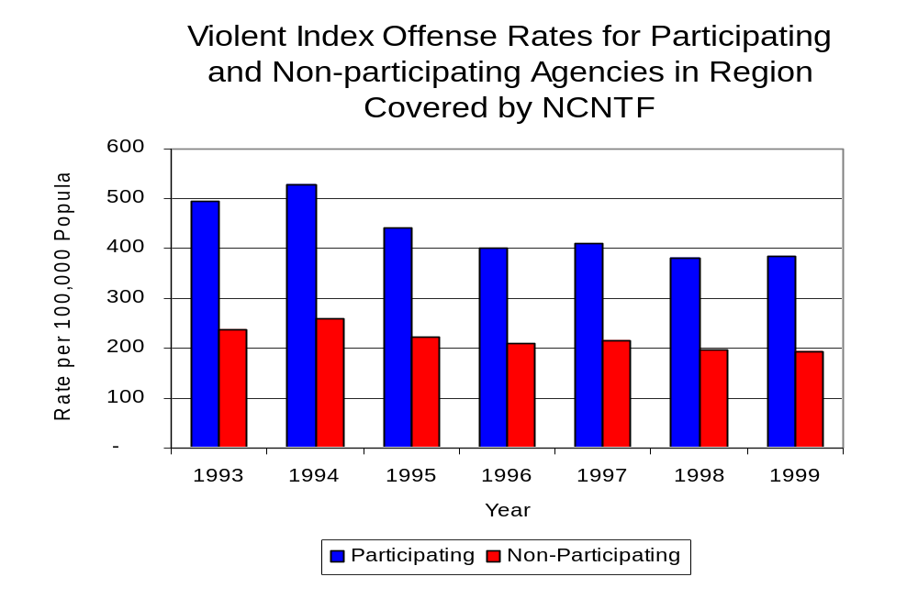
Source: ICJIA calculations using Illinois State Police
and U.S. Census Bureau data
Figure 1

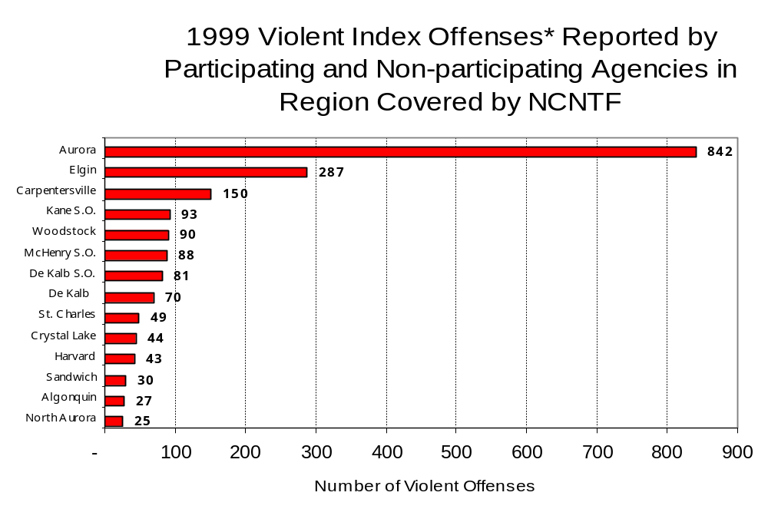
Across the 56 individual local law enforcement agencies covered by NCNTF’s jurisdiction, three agencies, the Aurora Police Department, the Elgin Police Department and the Carpentersville Police Department, accounted for 60 percent of all violent offenses reported to the police (Figure 2). Forty-one agencies had fewer than 25 violent offenses reported in 1999 and are excluded from Figure 2. When controlling for differences in the populations served by these law enforcement agencies, the violent Index offense rate ranged from 651 violent Index offenses per 100,000 population in Aurora to 262 offenses per 100,000 population in North Aurora.
Source: Illinois State Police *Agencies reporting 25 or more violent offenses
Figure 2

An indicator of the workload that law enforcement agencies place on other components of the justice system is the number of arrests made by police, including those for violent and property Index offenses and drug offenses. Unlike offenses, which are what police must respond to, arrests represent those offenders who may eventually be processed through other components of the justice system, including the courts, county jails, and state and local correctional programs.

Between 1993 and 1999, the number of arrests for violent Index offenses made by law enforcement agencies in the region covered by NCNTF increased 7 percent, from 940 to 1,010 As with reported violent Index offenses, the majority (81 percent) of violent Index arrests were for aggravated assaults, followed by robberies (11 percent).

During the period analyzed, the violent Index arrest rate for the region covered by NCNTF decreased 9 percent, from 144 offenses per 100,000 population in 1993 to 131 arrests per 100,000 population in 1999. Similarly, the violent Index arrest rate in the participating agencies decreased 23 percent, from 185 to 142 offenses per 100,000 population, while the rate in the non-participating agencies increased 10 percent, from 111 to 122 offenses per 100,000 population (Figure 3).

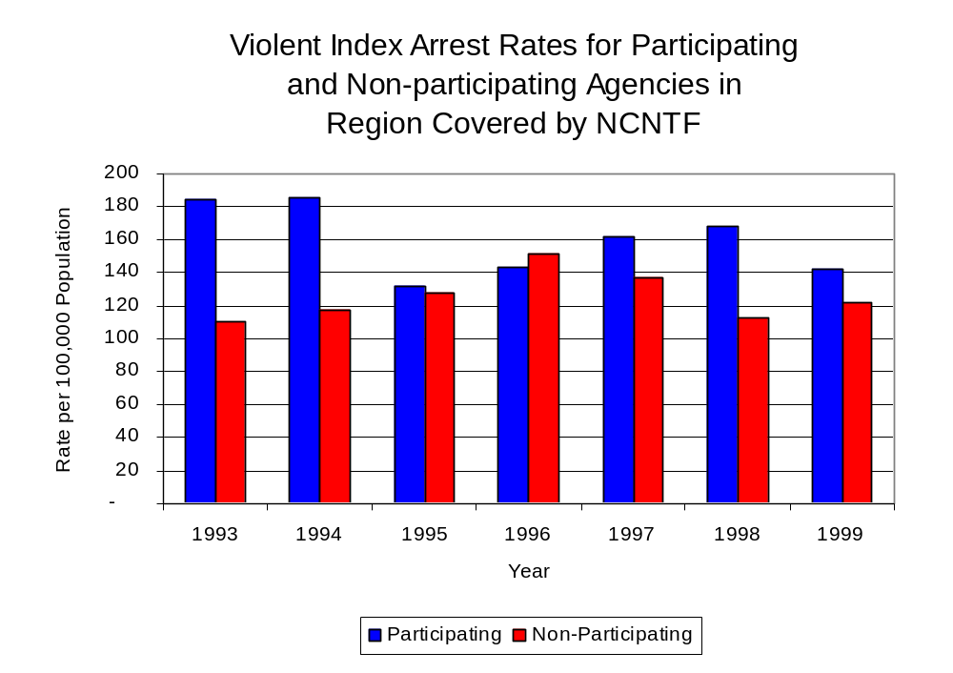
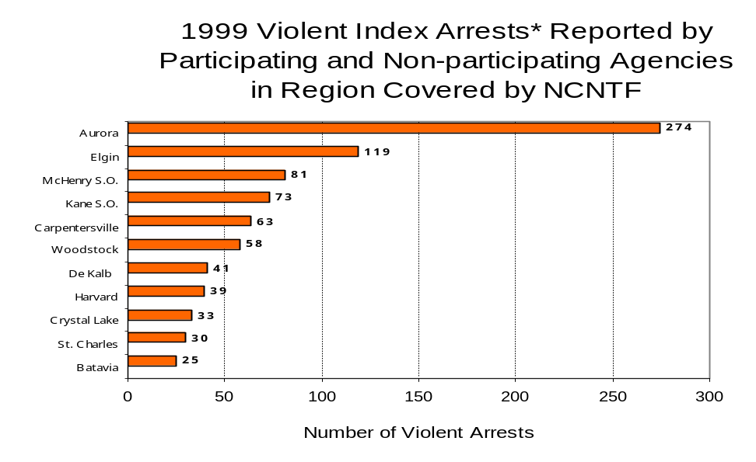
The majority (54 percent) of arrests for violent Index offenses occurring in the three-county region covered by NCNTF were made by four agencies. Forty-four agencies had fewer than 25 arrests for violent Index offenses reported in 1999 and are excluded from Figure 4. Of the 1,010 violent Index arrests made in 1999, the Aurora Police Department accounted for the majority (27 percent), followed by the Elgin Police Department (12 percent), the McHenry County Sheriff’s Office (8 percent) and the Kane County Sheriff’s Office (7 percent) (Figure 4).
Figure 3
Source: ICJIA calculations using
Illinois State Police and U. S. Census Bureau data

Figure 4
Source: Illinois State Police *Agencies reporting 25 or more violent offenses
III. Trends in Drug Arrests

There are two sources of drug arrest data presented in this section. One source is the Illinois Uniform Crime Reporting (I-UCR) program that includes information submitted by local law enforcement agencies on the number of persons arrested for violations of Illinois’ Cannabis Control Act, Controlled Substances Act, Hypodermic Syringes and Needles Act, and Drug Paraphernalia Control Act. In addition, data on drug arrests made by Illinois’ MEGs and task forces are reported to the Illinois Criminal Justice Information Authority. In some jurisdictions, arrests made by the MEG or task force may be reported by both local law enforcement agencies through the I-UCR and to the Authority by the unit. In other jurisdictions, arrests made by the MEG or task force are only reported to the Authority by the unit. Therefore, in some instances drug arrests may be double counted – included in both local agency statistics reported to I-UCR and those of the MEG or task force. Currently there is no mechanism in place to ensure that drug arrest statistics are not being duplicated at both the local agency and MEG/task force level. This should be kept in mind when interpreting the information presented in the following section.

The majority of drug offenses in Illinois are violations of either the Cannabis Control Act – which prohibits the possession, sale and cultivation of marijuana – or the Controlled Substances Act – which prohibits the possession, sale, distribution or manufacture of all other illegal drugs, such as cocaine and opiates. Illinois also has various other laws prohibiting other drug-related activity. These include the Hypodermic Syringes and Needles Act – which prohibits the possession or sale of hypodermic instruments – and the Drug Paraphernalia Control Act – which prohibits the possession, sale or delivery of drug paraphernalia. In general, violations of Illinois Controlled Substances Act are considered to be more serious, since they primarily involve cocaine, heroin, methamphetamine, and hallucinogens, and are almost all classified under Illinois law as felonies. The majority of cannabis and drug paraphernalia offenses encountered by police, on the other hand, tend to be misdemeanor-level offenses.

In 1999, local law enforcement agencies in the counties covered by NCNTF reported 4,138 arrests for drug law violations, more than double the 1,527 arrests reported in 1993. Between 1993 and 1999, arrests for violations of Illinois’ Cannabis Control Act consistently out-numbered arrests for violations of the Controlled Substances Act every year analyzed in DeKalb, Kane and McHenry counties combined. During the same period, the number of arrests for violations of the Cannabis Control Act in these three counties combined more than doubled, from 799 to 1,844. Arrests for violations of the Controlled Substances Act in the three counties combined, increased 36 percent, from 684 to 930. In addition, arrests for violations of the Drug Paraphernalia Control Act, enacted in 1993, increased from 18 in 1993 to 1,333 in 1999. Much of this increase can be attributed to a 1994 addition to the Drug Paraphernalia Control Act, which included the possession of drug paraphernalia as a violation.

Because arrests for violations of the Drug Paraphernalia Control Act are frequently made in conjunction with other drug offense arrests, these arrests may be double-counted, thus skewing the actual number of drug arrests. Therefore, only arrests for violations of the Cannabis Control Act and Controlled Substances Act will be used for drug arrest comparisons between NCNTF and the participating and non-participating agencies.

During the period analyzed, the drug arrest rate for violations of the Cannabis Control and Controlled Substances Acts combined, in the region covered by NCNTF increased 58 percent, from 228 arrests per 100,000 population in 1993 to 360 arrests per 100,000 population in 1999. Similarly, the drug arrest rate in the participating agencies increased 63 percent, from 238 to 388 arrests per 100,000 population, while the rate for non-participating agencies increased 54 percent, from 219 to 337 arrests per 100,000 population. The arrest rate for NCNTF also increased 9 percent, from 99 to 108 arrests per 100,000 population (Figure 5). Thus, the drug arrest rate tended to be slightly higher for those agencies participating in NCNTF than in those jurisdictions did not participate in NCNTF. The drug arrest rate achieved by NCNTF was less than the drug arrest rate achieved by both those agencies participating and those not participating in NCNTF. However, this may be due to the fact that NCNTF only has less than 1 percent of all the officers working in those agencies participating in NCNTF.
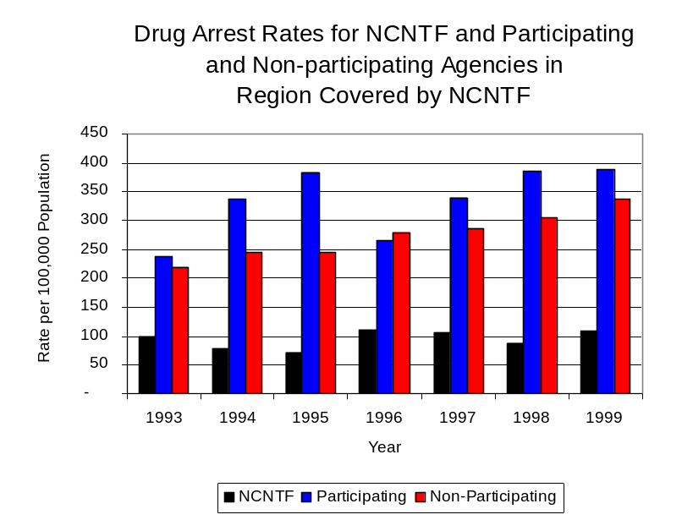
Source: ICJIA calculations using Illinois State Police, NCNTF and U.S. Census Bureau data
Figure 5

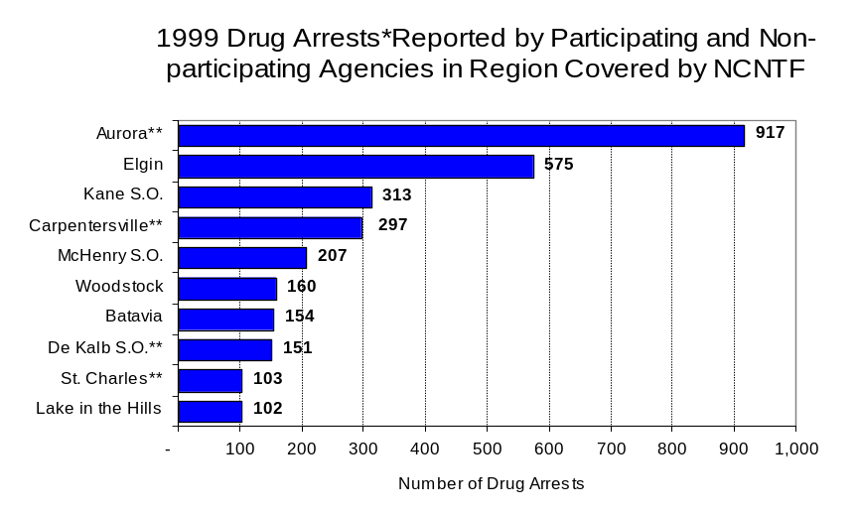
Across the individual local law enforcement agencies in the region covered by NCNTF, the total number of drug arrests, including all types of drug offenses, ranged from zero to 917. Of the 4,138 drug arrests made during 1999 in the three-county region, five agencies accounted for 56 percent of these drug arrests. Forty-five agencies had fewer than 100 drug arrests reported in 1999 and are excluded from Figure 6. Aurora accounted 22 percent, while the Elgin Police Department accounted for 14 percent, the Kane County Sheriff’s Office accounted for eight percent, the Carpentersville Police Department accounted for seven percent and the McHenry County Sheriff’s Office accounted for 5 percent of all drug arrests in DeKalb, Kane and McHenry counties (Figure 6). Of those agencies presented in Figure 6, four participate in NCNTF, including Aurora, which reported the highest number of drug arrests in the region.
Figure 6
Source: Illinois State Police *Agencies reporting 100 or more drug arrests
**Agencies participating in NCNTF

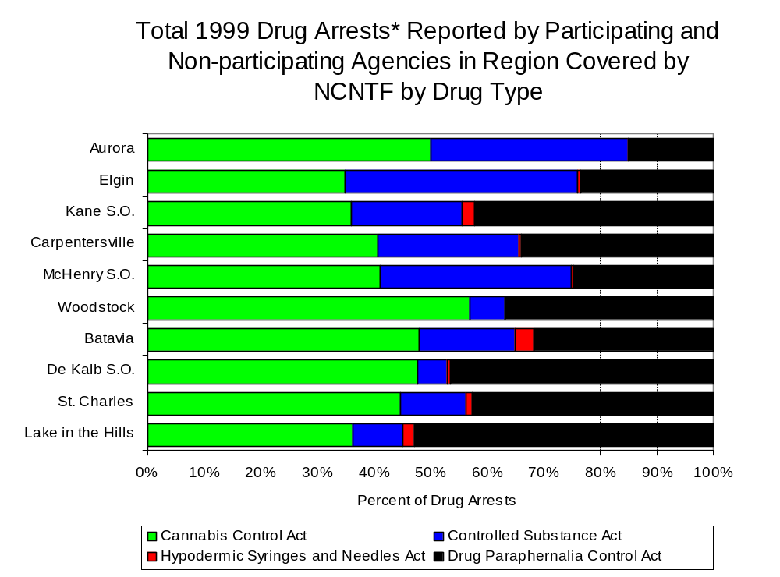
In addition to the dramatic difference in the number of drug arrests made, there are also differences in the types of drug law violation arrests across the agencies in the region. In 1999, violations of the Cannabis Control Act and the Drug Paraphernalia Control Act accounted for the majority of arrests across most individual agencies in the region covered by NCNTF (Figure 7).
Figure 7
Source: Illinois State Police *Agencies reporting 100 or more drug arrests

Between 1993 and 1999, the number of combined cannabis and controlled substances arrests made by NCNTF increased 28 percent, from 292 to 374 (Figure 8). Unlike drug arrests made by most local police departments in the region, violations of the Controlled Substances Act accounted for the majority of drug arrests made by NCNTF throughout most of the period analyzed.

During the period analyzed, the number of NCNTF arrests for violations of the Cannabis Control Act decreased 28 percent, from 122 to 88, while arrests for violations of the Controlled Substances Act increased 68 percent, from 170 to 286 (Figure 8).

Between 1993 and 1999, the proportion of drug arrests accounted for violations of the Controlled Substances Act decreased for participating and non-participating agencies. On the other hand, for NCNTF, the proportion of drug arrests accounted for by violations Controlled Substances Act increased 31 percent between 1993 and 1999. In 1999, 76 percent of the drug arrests made by NCNTF were for violations of the Controlled Substances Act, compared to 58 percent in 1993; whereas, in 1999, arrests for controlled substances violations accounted for 34 percent of the drug arrests made in the participating agencies and 33 percent for the non-participating agencies, compared to 51 percent and 42 percent, respectively, in 1993. Thus, NCNTF drug arrests were more likely than arrests by either participating or non-participating agencies to involved violations of the Illinois’ Controlled Substances Act, as opposed to the Cannabis Control Act. One interpretation of this pattern is that NCNTF is more focused in who they are targeting and arresting than local departments, and are also getting a more serious drug law violator, since violations of the Controlled Substances Act are more likely to involve felony-level offense.
The data presented below represent the percent of total drug arrests made by participating agencies that were accounted for by NCNTF. An upper and lower bound is shown in Figure 9, which accounts for whether or not the units numbers are counted as part of the UCR submissions made by participating departments (which is unknown at this point). The upper bound indicates the percentage of arrests if all of the NCNTF arrests are included in the local UCR submissions. The lower bound indicates the percentage if none of the NCNTF arrests are included in the local UCR submissions.
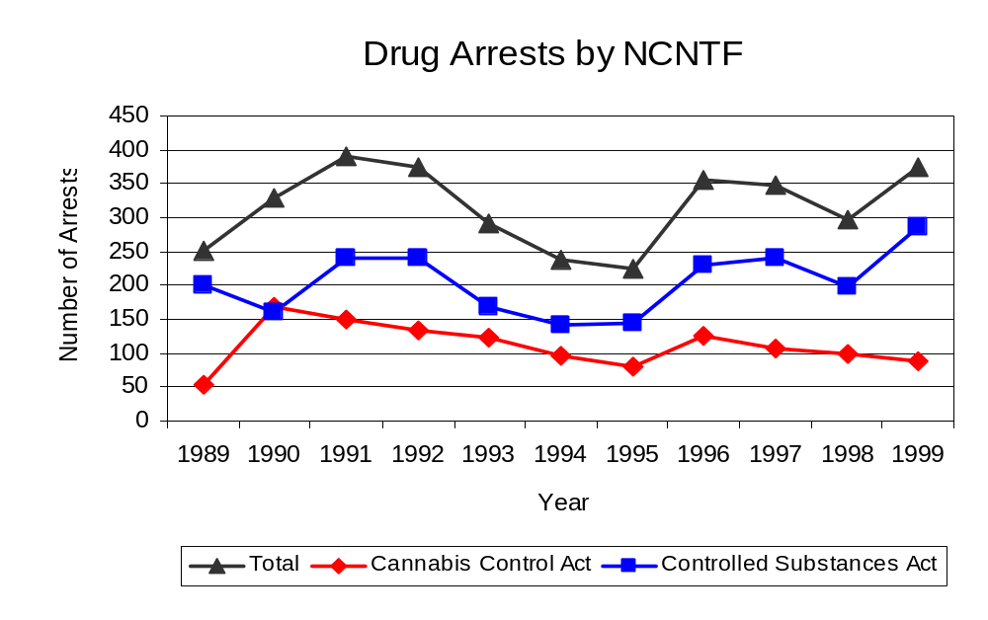
Source: NCNTF
Figure 8
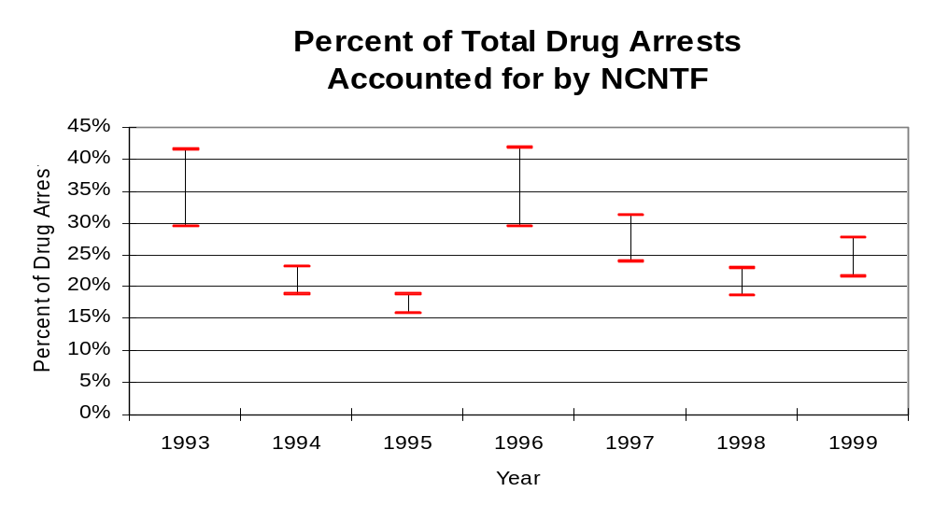
It is estimated that the proportion of all drug arrests made in the jurisdictions of participating agencies, and accounted for by NCNTF, was between 29 to 42 percent in 1993, but decreased to between 22 to 28 percent in 1999. Thus, despite the fact that the officers assigned to NCNTF accounted for a very small proportion of the total number of officers in participating agencies, they accounted for a relatively large proportion of the drug arrests made in the jurisdiction of the participating agencies in most of the years analyzed.
Figure 9
Source: ICJIA calculations using
Illinois State Police and NCNTF

The number of arrests for violations of Illinois’ Cannabis Control Act in DeKalb, Kane and McHenry counties totaled 1,844 in 1999, more than doubled the 799 arrests made for cannabis violations in 1993. Between 1993 and 1999, the proportion of all drug arrests accounted for by violations of the Cannabis Control Act in the three-county region increased 23 percent, from 54 percent to 66 percent. Agencies not participating in NCNTF accounted for the largest portion (52 percent) of the total number of arrests for cannabis violations. NCNTF reported a total of 88 arrests for cannabis violations in 1999, 24 percent of the unit's drug arrests.

During the period analyzed, the cannabis arrest rate for the region covered by NCNTF increased 95 percent, from 123 arrests per 100,000 population in 1993 to 239 arrests per 100,000 population in 1999. The cannabis arrest rate in the participating agencies more than doubled, from 117 to 258 arrests per 100,000 population, while the arrest rate in the non-participating agencies increased 76 percent from 127 to 224 arrests per 100,000 population. The cannabis arrest rate for NCNTF, on the other hand, decreased 39 percent, from 41 to 25 arrests per 100,000 population (Figure 10). Thus, the arrest rate for violations of the Cannabis Control Act was collectively higher in the area served by participating agencies than in the combine jurisdictions of the non-participating agencies.

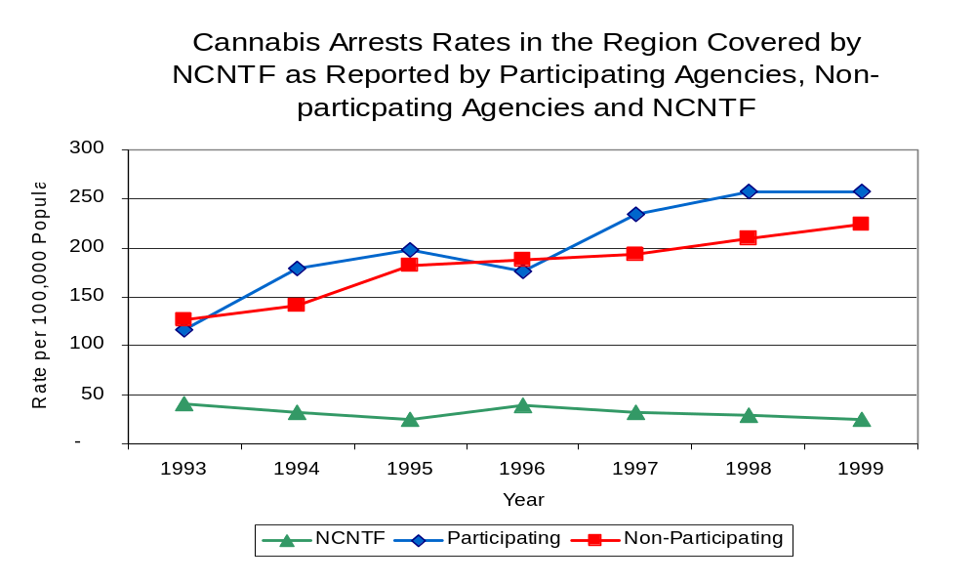
Source: ICJIA calculations using
Illinois State Police and NCNTF data
Figure 10

The data presented below represent the percent of total arrests for the violation of the Cannabis Control Act made by participating agencies that was accounted for by NCNTF. An upper and lower bound is shown in Figure 11, which accounts for whether or not the units numbers are counted as part of the UCR submissions made by participating departments (which is unknown at this point). The upper bound indicates the percentage of arrests if all of the NCNTF arrests are included in the local UCR submissions. The lower bound indicates the percentage if none of the NCNTF arrests are included in the local UCR submissions.

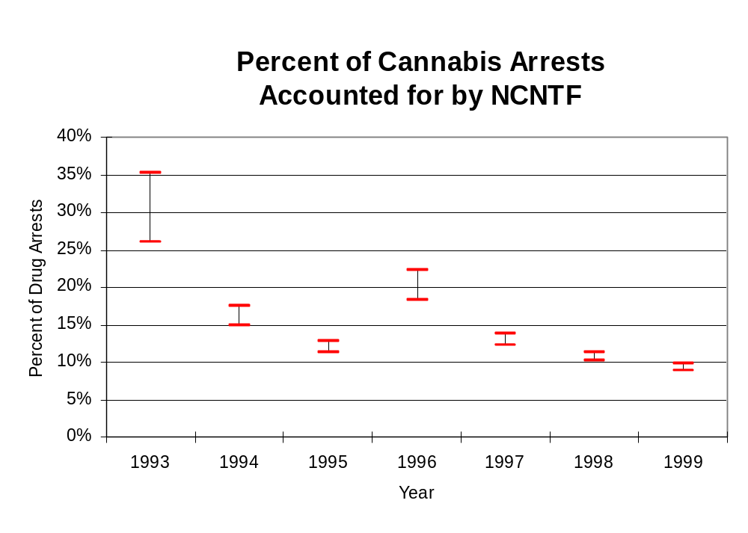
It is estimated that the proportion of all arrests for the violation of the Cannabis Control Act made in the jurisdictions of participating agencies, and accounted for by NCNTF, was between 26 to 35 percent in 1993, but decreased to between 9 to 10 percent in 1999. The data presented in Figure 11 suggest that although arrests for the violation of the Cannabis Control Act made by NCNTF in 1993 represented a large proportion of such arrests made in the jurisdictions of participating agencies, this proportion dropped in subsequent years.
Figure 11
Source: ICJIA calculations using
Illinois State Police and NCNTF data

In DeKalb, Kane and McHenry counties, the number of arrests for violations of Illinois’ Controlled Substances Act increased 36 percent between 1993 and 1999, from 684 to 930. Between 1993 and 1999, the proportion of all drug arrests accounted for by violations of the Controlled Substances Act in the three-county region decreased from 46 percent to 34 percent. In 1999, NCNTF reported 286 arrests for controlled substance violations, 76 percent of all drug arrests reported to the Authority by the unit.

Between 1993 and 1999, the arrest rate for controlled substances act violations for the region covered by NCNTF increased 15 percent, from 105 to 121 arrests per 100,000 population (Figure 12). The controlled substances arrest rate in the participating agencies increased 7 percent, from 121 to 130 arrests per 100,000 population, while the arrest rate in the non-participating agencies increased 23 percent, from 91 to 113 arrests per 100,000 population. The controlled substances arrest rate for NCNTF increased 43 percent, from 58 to 82 arrests per 100,000 population (Figure 12). Thus, the arrest rate for violations of the Controlled Substances Act was higher in the participating agencies than the non-participating agencies.

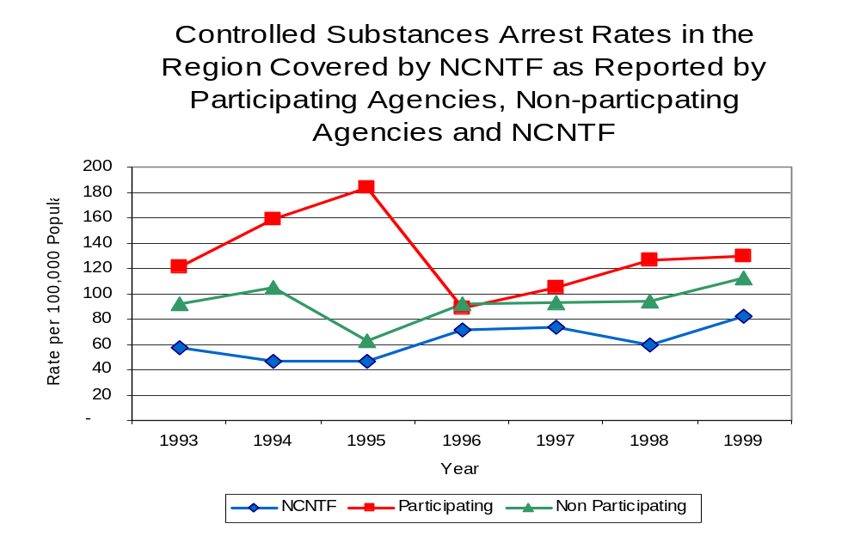
The data presented below represent the percent of total arrests for the violation of the Controlled Substances Act made by participating agencies that was accounted for by NCNTF. An upper and lower bound is shown in Figure 13, which accounts for whether or not the units numbers are counted as part of the UCR submissions made by participating departments (which is unknown at this point). The upper bound indicates the percentage of arrests if all of the NCNTF arrests are included in the local UCR submissions. The lower bound indicates the percentage if none of the NCNTF arrests are included in the local UCR submissions.
Figure 12
Source: ICJIA calculations using Illinois State Police and NCNTF data

It is estimated that the proportion of all arrests for the violation of the Controlled Substances Act made in the jurisdictions of participating agencies, and accounted for by NCNTF, was between 32 to 47 percent in 1993 and increased to between 39 to 63 percent in 1999. Thus, NCNTF accounted for a large portion of all arrests made for violations of the Controlled Substances Act, specifically since 1995. When examining the three figures together (Figure 9, 11 and 13), the data suggest that NCNTF focused on arresting individuals violating the Controlled Substances Act, most of which are felony offenses.

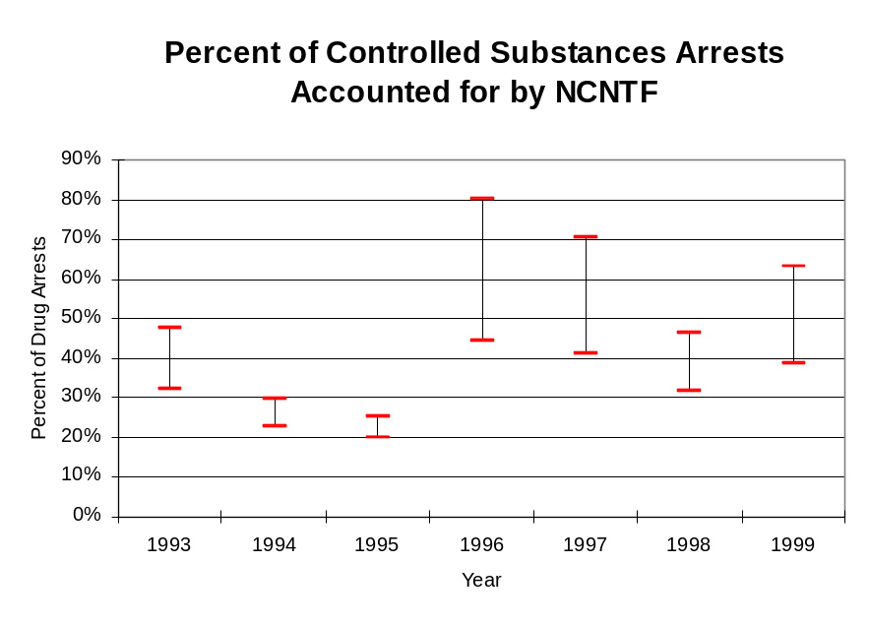
Figure 13
Source: ICJIA calculations using
Illinois State Police and NCNTF data
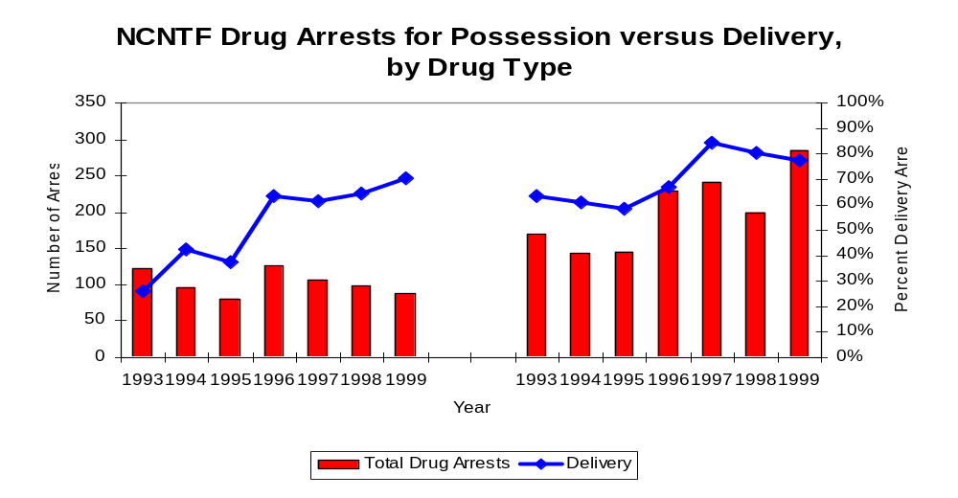
The majority of all drug arrests reported by NCNTF are for delivery. Between 1993 and 1999, the number of drug delivery arrests made by NCNTF more than doubled, from 140 to 284, and drug delivery offenses accounted for increasing proportions of arrests. Arrests for drug delivery accounted for 65 percent of all drug arrests made by NCNTF between 1993 and 1999. When cannabis and controlled substance arrests were examined separately, during the period analyzed, arrests for delivery of controlled substances accounted for 72 percent of the total number of arrests made for violations of the Controlled Substance Act, whereas, arrests for the delivery of cannabis accounted for 52 percent of all arrests for violations of the Cannabis Act.
Figure 14
Source: ICJIA calculations using NCNTF data
Cannabis Control Act

Controlled Substances Act

IV. Trends in Drug Seizures

Drugs seized by law enforcement agencies are another indicator of the extent and nature of illegal drug trade in a jurisdiction. When illegal drugs are seized by law enforcement agencies, all or a portion of the total amount seized is submitted to a crime lab for analysis. Most agencies submit drugs to one of the Illinois State Police crime labs. These labs record the quantity of drugs submitted from each county. This section discusses trends in the quantities of illegal drugs seized and submitted to the Illinois State Police from local law enforcement agencies in DeKalb, Kane and McHenry counties as well as the quantities of drugs seized by NCNTF. It is important to note, however, that while NCNTF data report the total quantities of drugs actually seized, local agency data only represent the quantities of seized drugs that are submitted to the Illinois State Police for analysis. County-level cannabis, cocaine and methamphetamine seizure rates for Illinois' 102 counties are provided in maps located in the Appendix of this report.

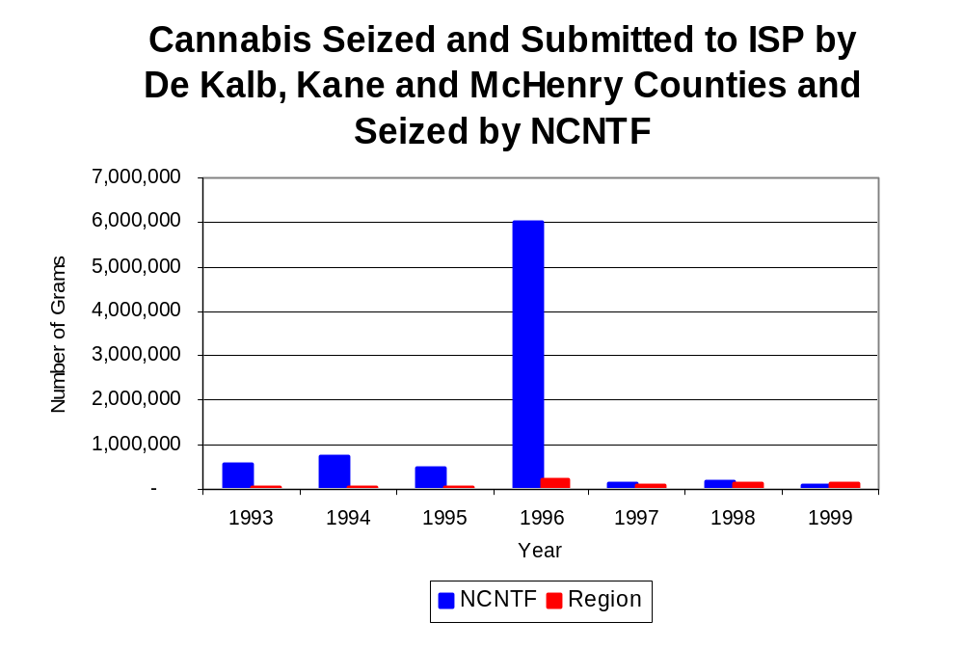
As in most Illinois jurisdictions, cannabis accounts for the majority of illegal drugs seized in the three-county region covered by NCNTF. The quantity of cannabis seized and submitted by law enforcement agencies in DeKalb, Kane and McHenry counties more than quadrupled, from 32,390 grams in 1993 to 137,915 grams in 1999, with 215,310 grams being seized in 1996, the largest amount seized during the period analyzed. However, the quantity of cannabis seized by NCNTF decreased 84 percent between 1993 and 1999, from 569,424 grams to 90,463 grams despite jumping to almost six million grams seized in 1996 (Figure 15). In 1999, NCNTF's cannabis seizure rate of 26,049 grams per 100,000 population was slightly lower than the statewide cannabis seizure rate of 31,533 grams per 100,000 population, but 46 percent greater than the seizure rate of 17,891 grams per 100,000 population in the three-county region covered by NCNTF (Map 2).
Figure 15
Source: Illinois State Police and NCNTF

Between 1993 and 1999, a combination of crack and powder cocaine has accounted for a small proportion of drugs seized in the three-county region covered by NCNTF. However, the quantity of cocaine seized and submitted by law enforcement agencies in DeKalb, Kane and McHenry counties almost tripled, from 6,231 grams in 1993 to 18,282 grams in 1999. Between 1993 and 1999, the quantity of cocaine seized by NCNTF increased 74 percent, from 8,687 grams to 15,144 grams.

As a result, the proportion of all cocaine seized accounted for by powder cocaine varied between 1993 and 1999. In 1996 proportion of all cocaine seized accounted for by powder cocaine dropped to 88 percent of the cocaine seized in the three-county region covered by NCNTF. For NCNTF, although powder cocaine accounted for the largest proportion of total cocaine seizures in every year examined, the proportion decreased from 99 percent in 1993 to 86 percent in 1999 (Figure 16). In 1999, NCNTF's cocaine seizure rate of 4,361 grams per 100,000 population was nearly double the cocaine seizure rate of 2,372 grams per 100,000 population in the three-county region covered by NCNTF, but 72 percent less than the statewide cocaine seizure rate of 15,735 grams per 100,000 population (Map 3).

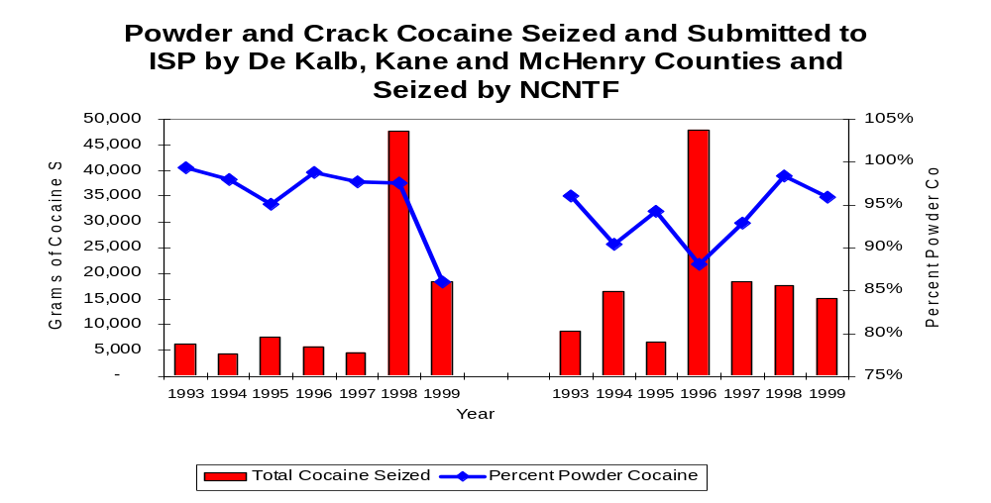
Figure 16
Source: Illinois State Police and NCNTF
NCNTF
Region

The total quantity of illegal drugs seized and submitted by law enforcement agencies in DeKalb, Kane and McHenry counties increased between 1993 and 1999, from 38,382 grams to 162,049 grams, with a high of 221,171 grams seized in 1996. On the other hand, the total quantity of illegal drugs seized by NCNTF has decreased 81 percent, from 578,426 grams in 1993 to 112,369 grams in 1999.

Between 1994 and 1999, NCNTF reported no methamphetamine seizures. During this period only 134 grams of methamphetamine were seized in the region covered by NCNTF, increasing from zero grams to 14 grams, with the largest amount (nearly 71 grams) seized in 1998. In 1999, the region covered by NCNTF had a methamphetamine seizure rate of two grams per 100,000 population, significantly lower than the statewide seizure rate of 98 grams per 100,000 population (Map 4).

Trends in Prosecutions for Drug Offenses and All Felonies

Although Illinois has one of the best court reporting systems in the country, the Administrative Office of the Illinois Court only collects information regarding the aggregate number of court filings. Currently, there are no statewide data available on court filings by offense type. The Administrative Office of the Illinois Courts reports data on felony criminal court cases. After screening a case and deciding it warrants further action, the state’s attorney must file formal charges in court. Felony cases can be punished by a probation term up to four years and incarceration for more than one year.

Between 1989 and 1999, the number of felony filings in the three-county region covered by NCNTF increased nearly every year. The number of felony filings increased 80 percent, from 3,243 to a period high of 5,833 (Figure 17).

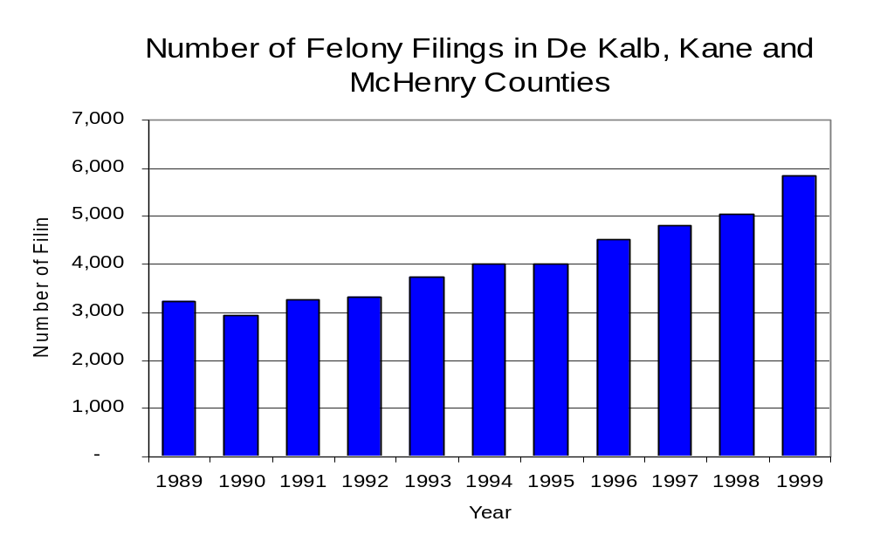
Figure 17
Source: Administrative Office of the Illinois Courts

Between 1989 and 1999, there were a total of 2,890 drug prosecutions initiated as a result of NCNTF arrests in DeKalb, Kane and McHenry counties. During this time, the number of NCNTF drug arrests increased 48 percent, from 253 arrests in 1989 to 374 arrests in 1999 (Figure 18). Between 1991 and 1999, approximately 83 percent of drug arrests by NCNTF resulted in prosecution. No prosecutions were reported in 1989. Sixty-five percent of NCNTF drug offender prosecutions during this period were for violations of the Controlled Substance Act. In some years, the proportion of arrests resulting in a prosecution exceeded 100 percent. This may be due to some differences in the timing of an arrest and the filings of charges, or could be due to the number of charges, rather than the number of defendants being reported by the unit. In addition, some offenders have charges filed, and a subsequent warrant issued, without an arrest taking place, which could also affect the number of prosecutions reported.
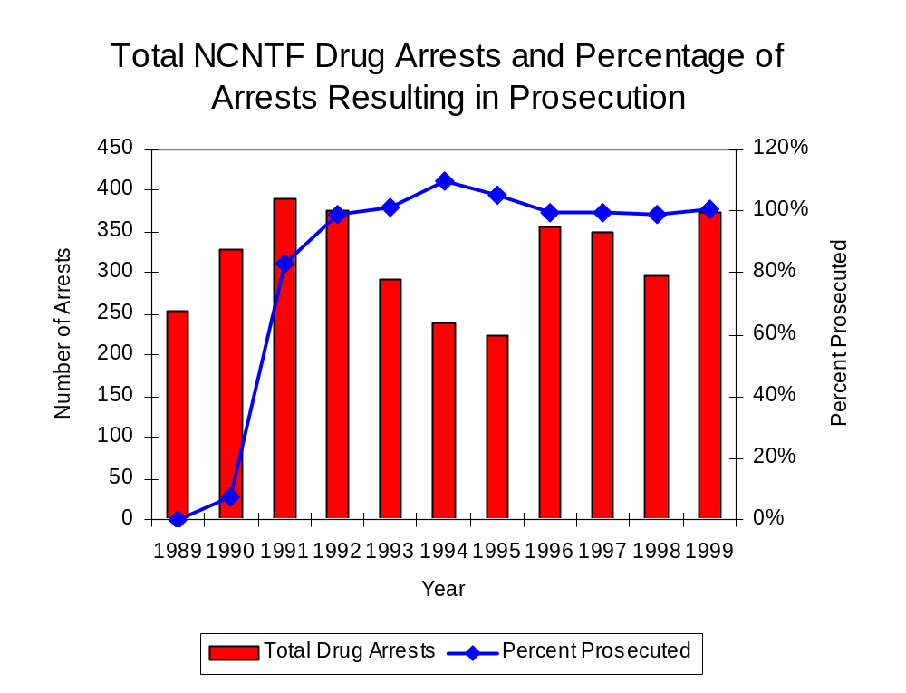
Figure 18
Source: NCNTF

Between 1989 and 1999, 65 percent (1,891) of the 2,890 drug offenders who were prosecuted as a result of NCNTF activity were convicted. Convictions for controlled substances accounted for 64 percent of all NCNTF initiated convictions during the period analyzed.

VI. Trends in Percent of Convicted Drug Offenders Sentenced to Prison

Anyone convicted of a felony in Illinois can be sentenced either to prison or probation, or receive conditional discharge. A number of factors influence the type and length of sentence imposed on convicted felons, including the severity of the crime, the offender’s criminal and social history, safety of the community and legislation affecting certain types of offenses. For some types of convictions, a sentence to prison is required by state statute.

Between 1989 and 1999, the number of offenders convicted of a felony and sentenced in the three-county region covered by NCNTF nearly tripled, from 1,022 to 3,019. Although the number of convicted felons sentenced to the Illinois Department of Corrections (IDOC) increased 56 percent between 1989 and 1999, from 576 to 897, the proportion of felons sentenced to IDOC decreased during the same period, from 56 percent to 30 percent of total felony sentences. In 1999, 1,720 probation sentences were imposed on convicted felons, more than triple the number of probation sentences in 1989 (Figure 19). As a result, the proportion of felons sentenced to probation increased from 43 percent in 1989 to 57 percent in 1999. Sentences other than prison or probation account for the remaining 13 percent of felony sentences imposed in 1999.
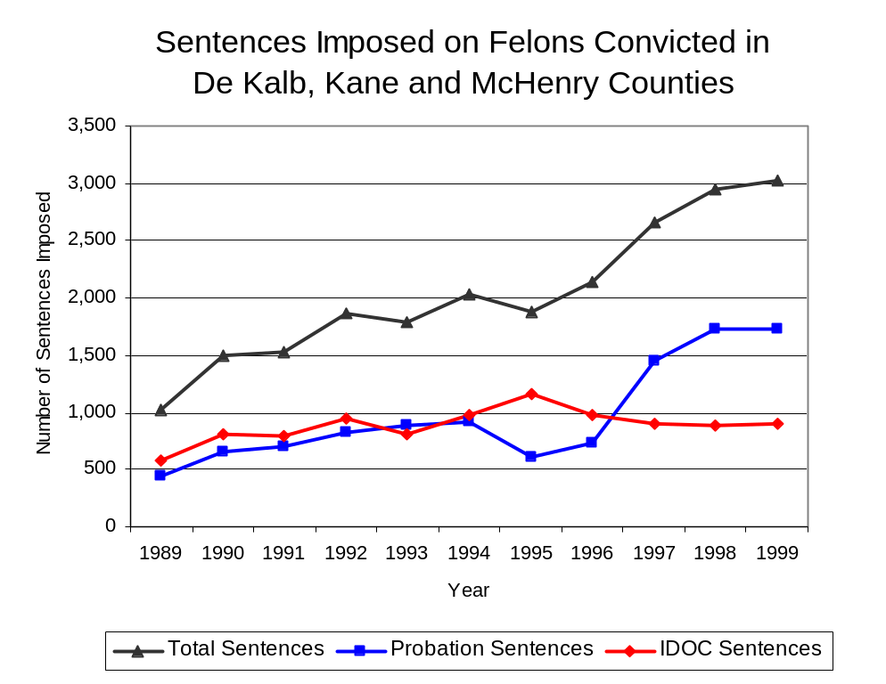
Figure 19
Source: Administrative Office of the Illinois Courts

Between 1989 and 1999, the number of NCNTF drug offenders convicted and sentenced increased from zero to 251. During the period analyzed, the number of convicted NCNTF drug offenders sentenced to probation increased from zero in 1989 to 93 in 1999, although in 1992, the number of convicted NCNTF drug offenders sentenced to probation reached an all time high of 178. Similarly, the number of convicted NCNTF drug offenders sentenced to jail increased from zero to 57 and the number of drug offenders sentenced to prison increased from zero to 101 (Figure 20). In 1999, among those NCNTF drug offenders convicted and sentenced, prison sentences accounted for the largest proportion (40 percent), followed by probation sentences (37 percent) and jail sentences (23 percent).

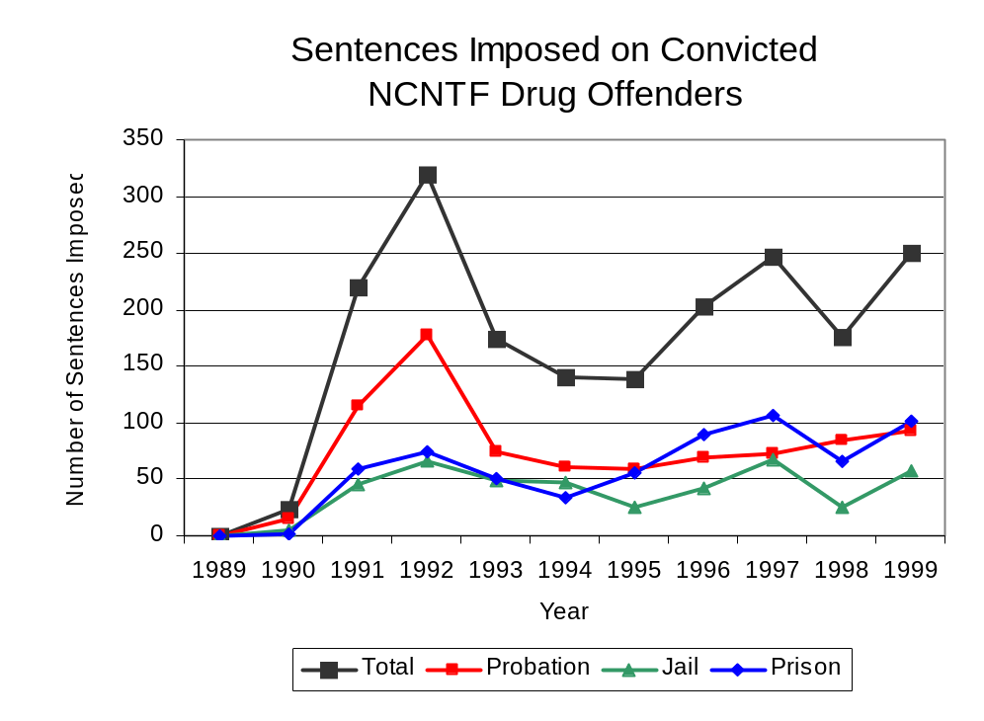
Figure 20
Source: NCNTF

Between state fiscal years 1989 and 1999, the number of new court commitments to IDOC’s Adult Division for drug offenses from the three-county region covered by NCNTF nearly quadrupled, from 67 to 258. The number of drug offender admissions by NCNTF also increased from zero to 67 between 1989 and 1999 (Figure 21). Thus, NCNTF accounted for 30 percent of all drug offenders committed to IDOC from the three-county region covered by NCNTF.
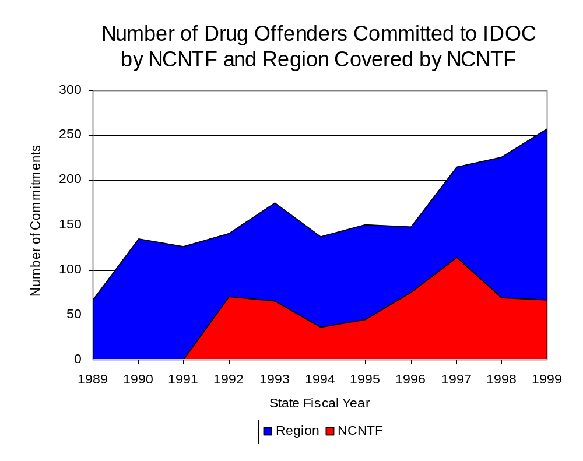
Figure 21
Source: Illinois Department of Corrections and NCNTF

During the period analyzed, drug offenders accounted for an increasing proportion of adults convicted and sentenced to prison from DeKalb, Kane and McHenry counties. In 1989, drug offenses accounted for 19 percent of all commitments to IDOC, compared to 34 percent in 1999 (Figure 22).

Source: Illinois Department of Corrections

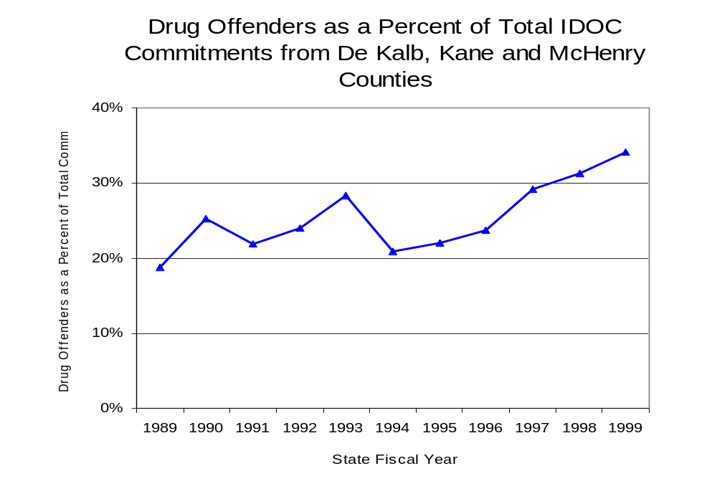
Figure 22
Source: Illinois Department of Corrections

Penalties for drug offenses were also examined between 1993 and 1999. Class 1 felonies accounted for the largest proportion (34 percent) of sentences to IDOC for drug offenses, followed by Class 4 felonies (30 percent), Class 2 and Class X felonies (17 percent and 14 percent, respectively) and Class 3 felonies (4 percent). Between 1993 and 1999, the number of Class 1 felony increased from 18 to 99, while Class 4 felony sentences increased 74 percent, from 43 to 75. Class 2 felony sentences also increased from 25 to 39, as did the number of Class X felonies, from 12 to 42. However, the number of Class 3 felonies remained relatively unchanged during the period analyzed (Figure 23).

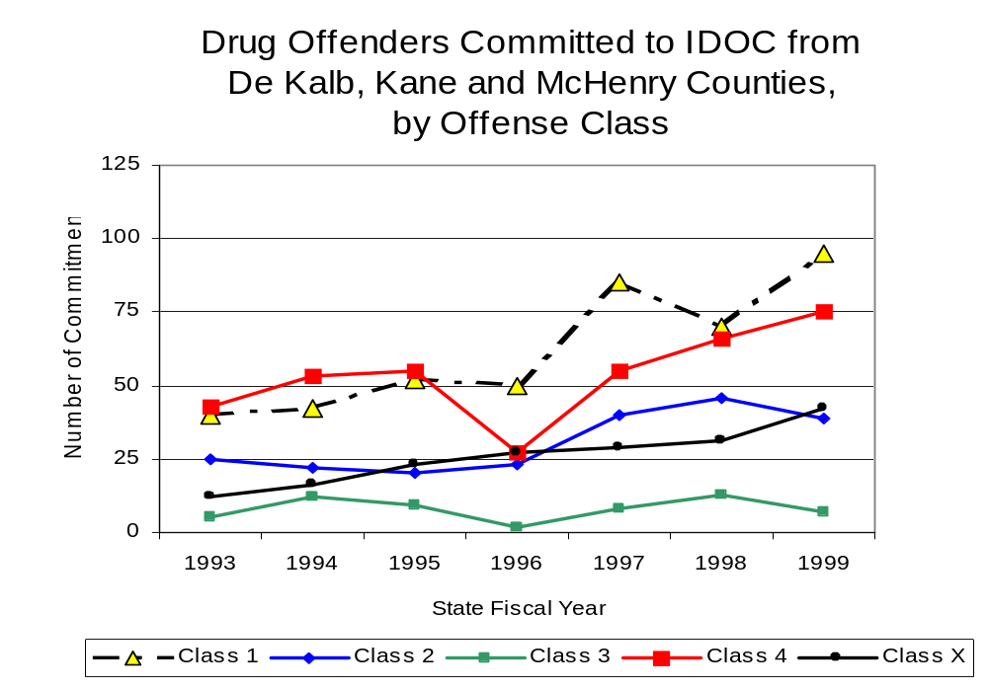
Figure 23
Source: Illinois Department of Corrections

Despite the dramatic increase in Class 4 felony sentences to IDOC between 1993 and 1999, the mean sentence length for Class 4 felonies decreased slightly from 2 to 1.9 years. However, the mean sentence length for Class X felonies increased from 7.6 to 9.4 years, while the mean sentence for a Class 1 felony remained relatively stable, and Class 3 sentence lengths decreased from 4.3 to 3 years. In addition, the mean sentence length for Class 2 felonies decreased slightly during the period analyzed.

Based on data collected from the 2000 Illinois Adult Probation Outcome Study, 17.4 percent of all adults discharged from probation in DeKalb, Kane and McHenry counties combined during the study period (November 2000) were convicted of drug-law violations. Of these drug-law violators discharged from probation in the region, three-quarters (75 percent) had been convicted of a felony drug offense. In addition, more than three-quarters (87.5 percent) of these drug-law violators were ordered to participate in some form of treatment

VII. Trends in Drug Treatment Admissions in NCNTF Region by Drug Type

In addition to considering indicators of the extent and nature of drug abuse as reported through the criminal justice system (for example, arrests and prison sentences), there are indicators of substance abuse available from other Illinois social service agencies. Overseeing and supporting treatment for substance users, whether they are referred from the criminal justice system or elsewhere, is the responsibility of the Illinois Department of Human Services’ Office of Alcoholism and Substance Abuse (OASA). It is important to note, however, that while OASA data represent the majority of the overall demand for substance abuse treatment in the state, some private programs provide treatment services to a smaller but significant number of clients who may not be included in the state’s reporting system.

In state fiscal year 1999, OASA reported 4,126 admissions for alcohol or drug abuse treatment from DeKalb, Kane and McHenry counties, 37 percent more than the 3,018 admissions in 1989 (Figure 24). Among the 4,126 admissions to substance abuse treatment in state fiscal year 1999, 47 percent (1,950) reported alcohol as their primary substance of abuse, while abuse of illicit substances accounted for 48 percent. Five percent reported no primary substance of abuse.

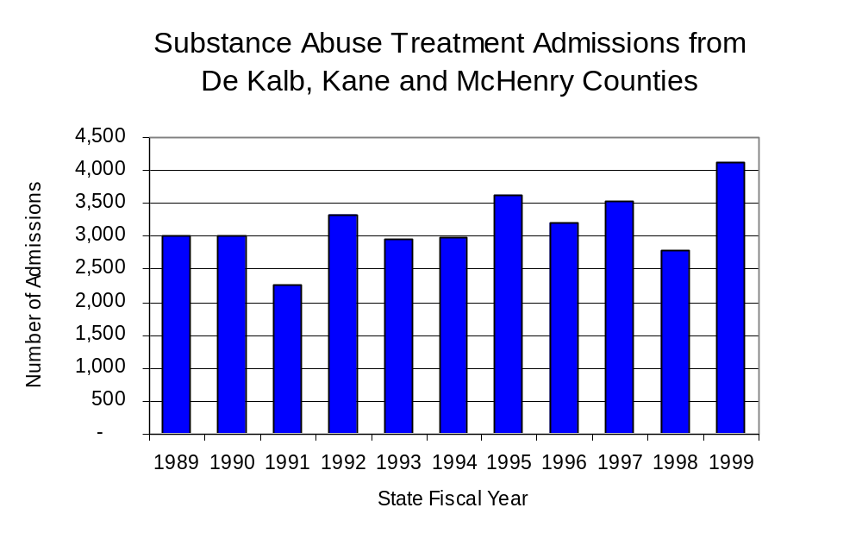
Figure 24
Source: Illinois Department of Human Services’
Office of Alcoholism and Substance Abuse
While drug treatment admissions can be considered a measure of the demand placed on a specific component of the human services system within Illinois, the extent and nature of drug treatment admissions could also be indicative of the substance abuse problem within a particular region. In some respects, the characteristics of those admitted to drug treatment can be considered a profile of the most serious drug abusers in the community, since admission to treatment requires a documented, formal assessment of a drug problem and a level of substance abuse warranting treatment. By comparing the types of drugs of abuse reported by those admitted to substance abuse treatment with the types of drugs involved in law enforcement agency arrests, one can get a sense of the degree to which arrests reflect the drugs which are most problematic within a community.

In the following analyses, the percent of arrests accounted for by drugs classified under Illinois’ Controlled Substances Act (primarily cocaine, heroin, and methamphetamine) versus the Cannabis Control Act (marijuana) across the participating agencies combined, non-participating agencies combined and NCNTF are compared to the proportion of drug treatment admissions accounted for by these groups of substances. From these comparisons, a number of general conclusions can be made. First, the proportion of arrests made by NCNTF accounted for by drugs other than marijuana (Controlled Substances Act offenses) was very close to the proportion of drug treatment admissions from the covered region accounted for by these substances. Thus, there is considerable convergence between the drugs involved in NCNTF arrests and treatment admissions. On the other hand, the majority of arrests by local police departments (including those participating in NCNTF and non-participating agencies) were for cannabis offenses. Thus, while local arrests may reflect the most widely available and used drug in the region, they did not tend to involve the substances considered to be most serious (i.e., felony versus misdemeanor) nor the substances for which individuals were seeking and receiving treatment (Figure 25).

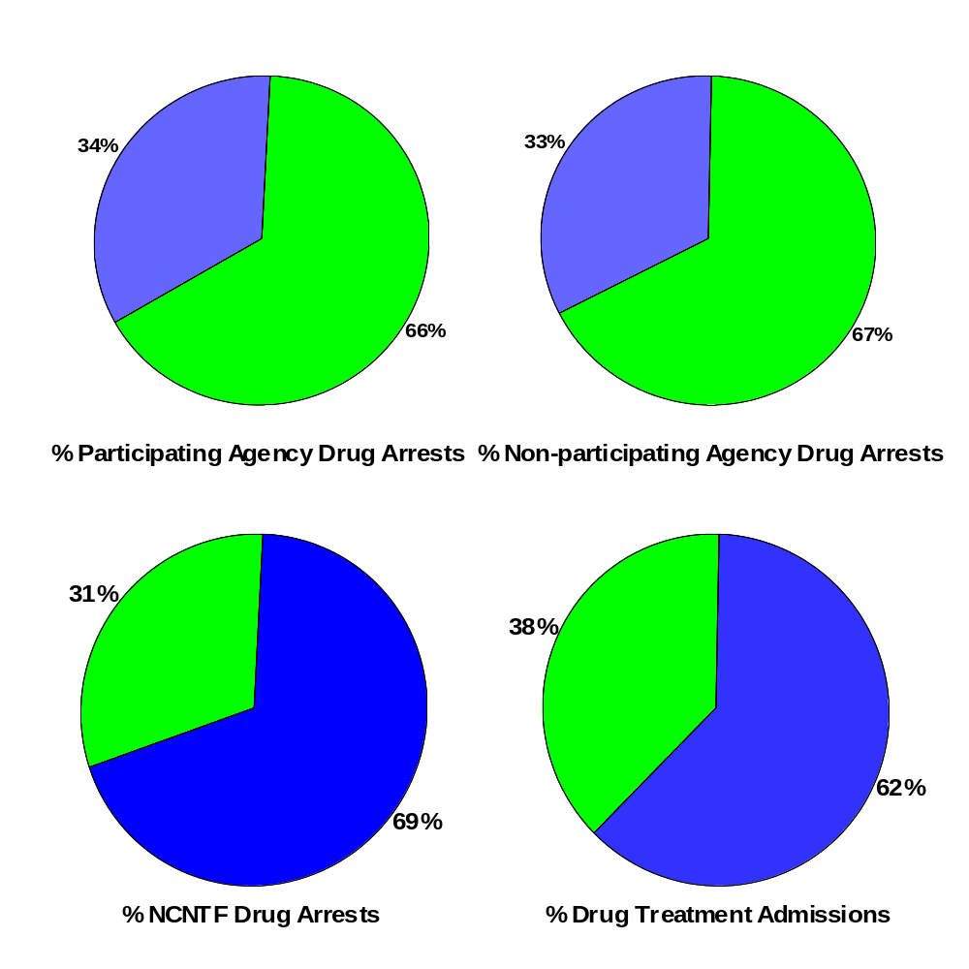
CannabisControlled Substances
Comparison of Drug Arrests by MEGSI and Participating and Non-participating Agencies vs. Drug Abuse Treatment Admissions in DeKalb, Kane and McHenry Counties, 1999
Source: Illinois Department of Human Service's Office of Alcoholism and Substance Abuse and NCNTF
Figure 25

VIII. Trends in Drug Exposed Births

Illinois continues to experience the effects of prenatal substance abuse. In Illinois, if a baby is born and thought to have been exposed to illegal substances or alcohol, either through observation by physicians or toxicology tests, the case is reported to the Illinois Department of Children and Family Services. These cases are then investigated by DCFS to verify the child’s prenatal exposure to either alcohol or illegal substances. Between state fiscal years 1989 and 1999, nearly one-half (50) of Illinois’ 102 counties reported at least one case of a substance-affected infant.

Between state fiscal years 1989 and 1999, the number of drug-exposed infant cases reported in the three-county region covered by NCNTF decreased five percent, from 40 to 38 reported cases; however, between 1992 and 1995, the number of cases reported reached over 50 each year. Between state fiscal years 1989 and 1999, 408 cases, or 88 percent of all cases reported, were verified as involving prenatal drug use by a DCFS investigation. Mirroring the trend of reported cases, verified cases of drug-exposed infants in the NCNTF region also decreased between 1989 and 1999 from 36 to 33, again with an increase in verified cases between 1992 and 1995 (Figure 26).

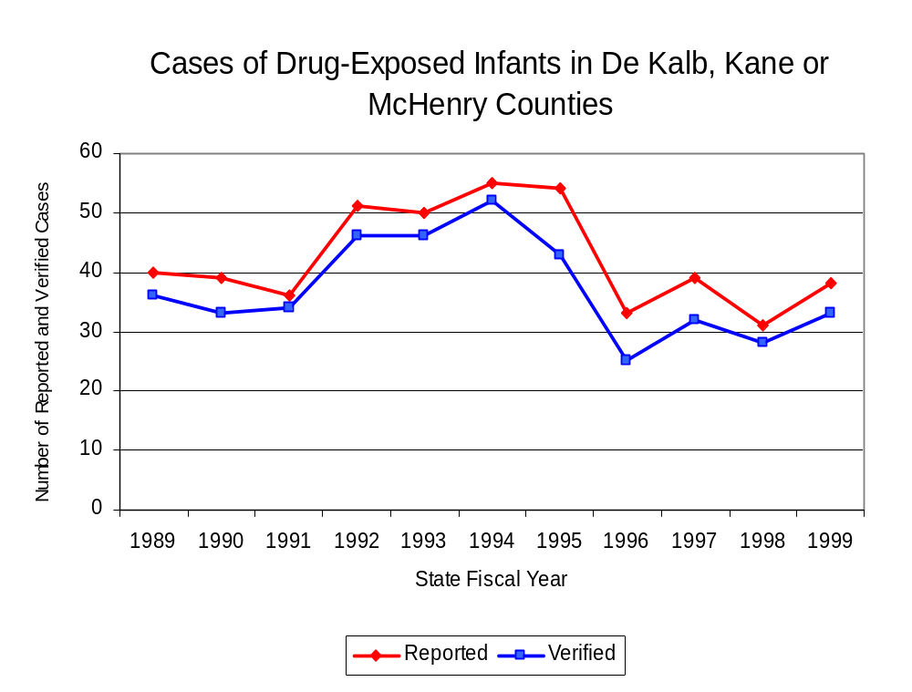
Source: Department of Children and Family Services
Figure 26

IX. Summary of Drug Situation

Although the distribution of illegal drugs is difficult to measure precisely, data obtained from criminal justice sources can be helpful in estimating drug availability. Information from a recent survey of Illinois drug enforcement units, as well as the most up-to-date data available on drug price, are presented as indicators of the drug supply in Illinois.

In 1995, 1996 and 1998, the Authority conducted a survey of each MEG and task force in Illinois to gauge the perceived availability of drugs in the areas they cover. Questions were asked concerning the availability of specific drugs, and results were analyzed by region of the state. MEGs and task forces are classified as being either urban, rural or mixed urban/rural based upon the classification of the county(s) that each unit covers, and, for purposes of this report, are compared to the average of similar units.

According to NCNTF survey responses, cannabis and crack continued to be the most visible drugs on the street and were all reported to be “readily available” across all regions analyzed. While perceived availability of cannabis remained relatively unchanged in the three-county region covered by NCNTF, the perceived availability of crack increased slightly since the 1996 survey, while all other drug types decreased in the region covered by NCNTF. Methamphetamine was reported as moderately available across Illinois but available to a somewhat lesser degree in the region covered by NCNTF and by all MEGs and task forces in mostly urban regions. The perceived availability of all drugs, excluding cannabis, tended to be greater across Illinois and in other mostly urban regions than in the region covered by NCNTF (Figure 27).
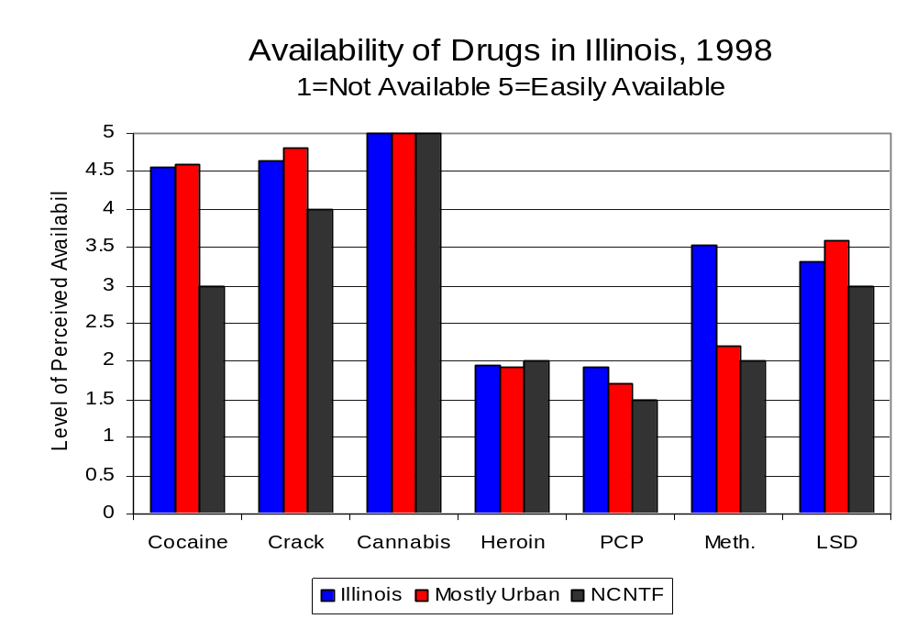
Figure 27
Source: Authority Survey of Illinois MEGs and task forces
Another market indicator that can be used to assess availability is drug price. Lower prices tend to suggest a sufficient supply to meet demand, while increasing prices indicate decreased availability.

Based on a statewide survey of MEG and task force units, the average price of cocaine and methamphetamine appear to be relatively stable across all regions surveyed in 1998, while prices for PCP and heroin appear to vary somewhat across Illinois. The average price of cannabis, cocaine and heroin in the region covered by NCNTF increased between 1996 and 1998, while it decreased in the other mostly urban regions. The biggest difference reported between 1996 and 1998 was the change in the price of crack. In 1996, the price of crack was reported as $150 per gram in the region covered by NCNTF, but according to the 1998 survey, the price of crack dropped to $60 per gram. The 1998 average price of cocaine reported by NCNTF was $100 per gram, compared to $98 per gram across Illinois and $89 per gram reported by all MEGs and task forces in other mostly urban regions (Figure 28). On the other hand, the average price of heroin in the region covered by NCNTF was reported as $133 per gram, lower than the price of $165 per gram across Illinois and the price of $137 per gram reported by all other MEGs and task forces in mostly urban regions. In 1998, the average price of cannabis was reported as approximately $25 per gram in the NCNTF region, $11 per gram in mostly urban regions and $8 per gram across Illinois.

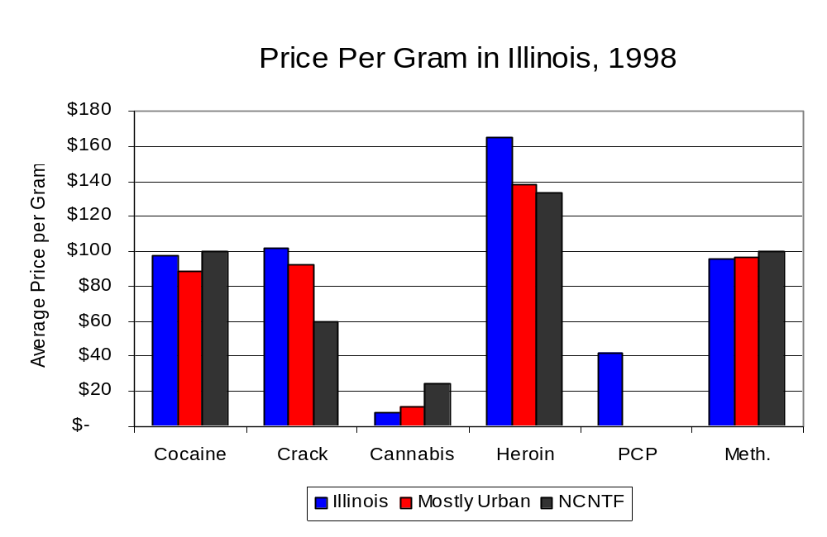
Figure 28
Source: Authority Survey of Illinois MEGs and task forces

X. Appendices
1999 Percent of Illinois'
County-level Population Covered by an Authority-funded Multi-jurisdictional Enforcement Group or Task Force
Map 1
* Shaded counties indicate that at least one law enforcement agency within the county participates in a MEG or task force
Percent of County Population Covered by MEG or Task Force

1999 Illinois
Cannabis
Seizure Rates, by County
Map 2
Cannabis Seizure Rate
(rate per 100,000 population)
1999 Illinois
Cocaine
Seizure Rates, by County
Map 3
Cocaine Seizure Rate
(rate per 100,000 population)
1999 Illinois Methamphetamine
Seizure Rates, by County
Map 4
Methamphetamine Seizure Rate
(rate per 100,000 population)
XI. Bibliography

Administrative Office of the Illinois Courts, Annual Report to the Supreme Court of Illinois.
1989 through 1999 reports, Springfield, Illinois.

Administrative Office of the Illinois Courts’ Probation Division, Statewide Probation Data
Report. 1989 through 1999 reports, Springfield, Illinois.

Illinois Department of Human Services’ Office of Alcoholism and Substance Abuse. Data
provided for state fiscal years 1989 through 1999, Springfield, Illinois.

Illinois Department of Children and Family Services, Child Abuse/Neglect Statistics Report,
1989 through 1999 reports, Springfield, Illinois.

Illinois Department of Corrections. Data provided for fiscal years 1989 through 1999,
Springfield, Illinois.

Illinois State Police, Crime in Illinois. 1993 through 1999 reports, Springfield, Illinois.

Illinois State Police, Drug Statistics Report. Monthly reports, January 1989 through
December 1999, Springfield, Illinois.

North Central Narcotics Task Force. Monthly reports, January 1989 through December
1999, Elgin, Illinois.

U.S. Bureau of the Census.


George H. Ryan, Governor
Peter B. Bensinger, Chairman
Candice M. Kane, Executive Director

